

2009 Dealer Manual
From initial contact - to the sale - to installing a Cascade Swimming Pool
Dealer Section: Laurence E (Larry) Ogden - Installation Section: Myles D Ogden

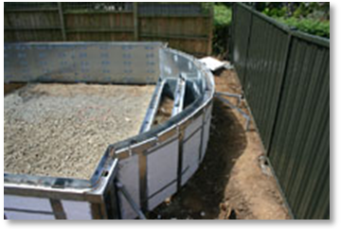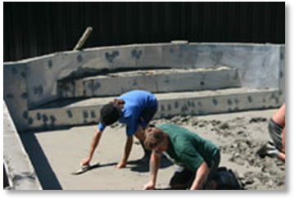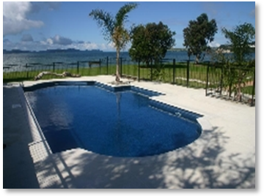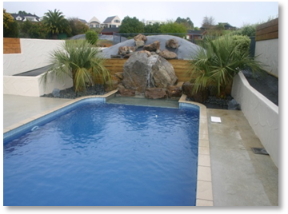

Rev. 01/2008
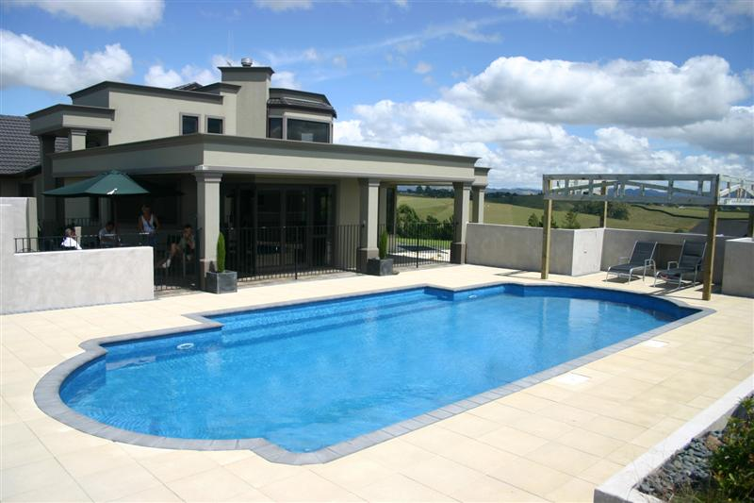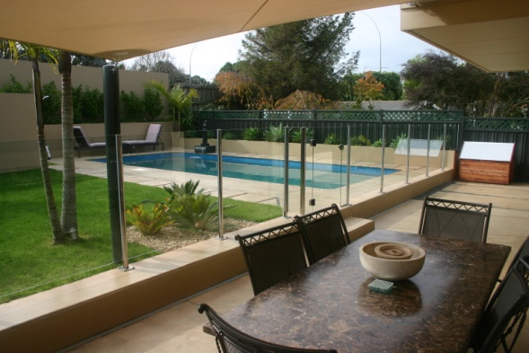

Alphabetical Index Page

A Successful sale! - 20 -
Advertising - 6 -
An Introduction to Cascade - 1 -
Aquagenie skimmer/chlorinators - 5 -
Building Approvals - 23 -
Classic pool range - 3 -
Customer Payment Terms - 22 -
Dealing with “the man of the house” - 13 -
Dealing with customer telephone calls - 10 -
Dealing with the lady buyer: - 12 -
Dealing with the lady of the house: - 12 -
Don’t Rubbish the opposition! - 14 -
Following up the Quotation - 19 -
Making Site meetings - 12 -
No Negatives - 18 -
Ordering the Pool Kit - 23 -
Paying for the Pool Kit - 25 -
Presenting yourself - 19 -
Product Inquiries - 9 -
Product Inquiry Sheets - 10 -
Quotation Forms - 17 -
Sales Inquires - 6 -
Signing the “Contract” - 21 -
The Brochure Pack - 11 -
The Cascade roadmap ………………………………………………………………………………... - 6 -
The Cascade Roadmap - 6 -
The Deposit - 22 -
The selling price calculation - 2 -
The site meeting. - 12 -
Ultimate pool range - 5 -
Variation to Sale & Purchase Agreement - 26 -
What to do if turned down! - 20 -
Yellow Pages - 6 -

Annex A Brochure Pack contents
Section Two Pictorial of Ultimate pools
Section Three Installation Manual
Section Four Sample newsprint ads
Section Five Equipment brochures

An Introduction to Cascade

September 2008
On the introduction of the Ultimate pool system in 2002, Cascade adopted a new policy with regard to its Country Dealers.

We realized that what happens in Auckland need not dictate what will happen in country areas - especially those that do not share in the rapid economic growth that was experienced here in the "Big Car Park" between 2000 and 2008. Accordingly, we made some changes to the product mix in order to offer country buyers a better choice (read: "lower cost") when it comes to choosing their swimming pool.

I wanted to design the “Best pool in the world” and starting with a clean sheet of paper, I wrote down a list of priorities for this new pool:

- Durable construction, esp. with regard to the sand/cement pool floors which could easily look “old” in a few short years as underground water affected the finish.

- Better insulation: we had been offering 50mm foam insulation, but tests revealed that the optimum thickness for foam with 100% heat retention is 90mm

- More environmentally conscious equipment esp. with chlorine and chloramines gas emissions and the associated handling issues with dangerous pool chemicals

- Easier construction procedures. Those of you who have spent years string-lining Classic pool floors, then spending an entire day with three workers hand mixing, wheel-barrowing and plastering the Classic pool floors with an 8:1 sand/cement plaster will appreciate this improvement.

- Upgraded pool liners: No longer the South African Vynide product, we wanted a thicker, more durable liner product, produced by a more experienced liner fabricator on modern equipment, including the ability to install internal seats, love seats, egress and entry areas, as we had become disillusioned with the fiberglass steps and their color matching difficulties.

- I wanted a product that would justify the description “The BEST POOL in the world”. In fact, the ULTIMATE pool!

Accordingly the Ultimate pool was introduced incorporating 25mpa high density shotcrete concrete, 90mm refrigeration grade self-draining insulation foam, the Aquagenie skimmer/chlorinator teamed up with Ozone, new floor shapes – particularly central deep ends of 1,800mm so that kids can dive into the pool from any angle towards the deepest part, yet allow pool games such as netball without putting some of the players in “the deep end”, and finally an upgrade from Nylex (or Vynide) .57mm to Nylex .75mm superior pool interior.
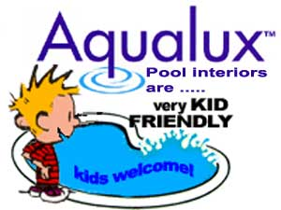

This new model allowed us to compete with the “top end” of the pool market, and has completely changed our market sector.

In order to maintain our popularity with the middle and lower end of the market, we kept the old Classic pools on our pricelist for a few years, but found fewer and fewer buyers as the pool buying public in Auckland preferred the more up-market Ultimate pool.

Recently, we have all but dropped the Classic range from our pricelist, and instead have introduced three versions of the Ultimate pool, the Good, the Better, and the Best ranges. The “Better” is our biggest selling range, and the “Good” pool is only a few thousand more than a Classic pool that has been upgraded with better liner, foam and Ozone – so there seems little point in maintaining that range.

As the Ultimate pool gains in popularity in country areas, we have reduced the price on the remaining Classic pool kits in stock, but as these comprise only a small percentage of our sales as this is written we may not be restocking these panel kits unless there is a strong demand for them. As we order these panel kits in lots of 100, once the existing stock is gone, the price will rise for “one off” orders.

We have found that if we start with a Classic pool, and upgrade to the expected high quality pool equipment these days – including Ozone - plus add a concrete floor (to save time and add durability) the price gap between the upgraded Classic pool and the basic Ultimate pool is quite minimal in the scheme of things. Hence our current “Good – Better – Best” pool price list we are using which lists a basic Ultimate at a very low retail price. This model ULTIMATE pool could be used in "price sensitive" areas rather than the Classic pool.

Some Cascade dealers are using - with great success - the Auckland pricelist, which is also published on the web site and has some country Dealer pricelists as well.

Others find the Auckland prices too difficult to achieve in their patch, due mainly to "one man bands" or locally established family pool builders who utilize cheap family labor to build their pools.

In these cases, we will produce a Retail price list tailored to your requirements. Just Ask! We will also add this to our POOL COST web page, with your area having its own click button to your own pool price list. Several of the Dealers use this facility.

Typically your opposition builders will offer only fiberglass or concrete pools – sprayed or plastered block - as these require little skill or expertise to install or produce in their basic form. They sell these for low prices in some cases, for the following reasons:

- Lower reward expectations on the part of your competition - e.g. they work for lower returns than Auckland tradesmen.

- Cheaper material/construction costs than in the main centers. (This would apply to you as well).

- Few business skills on the part of the builder, often self-taught semi laborer types who do not understand the disciplines of running a "proper" business.

The retail that we work on is based on a formula cost + overheads + profit margin+ GST.

The selling price calculation
for this is:

Sale-price = ((Cost+15%)+25%) or as follows:

If you use Microsoft’s excellent Excel spreadsheet (part of Microsoft Office 2004 or the latest version MS Office 2007) you can use the following to work out your pool selling prices:
 | A | B | C | D
1 | cost | 15% | 25% | 12.50%
2 | 25000 | 28750 | 35937.5 | 40429.69
3

Enter your installed cost into cell A2
In cell B 2 type “ =+A2*B1+A2” (enter)
In cell C 2 type “ =+B2*C1+B2” (enter)
In cell D 2 type “ =+C2*D1+C2” (enter)

If you intend to copy the formulae down several lines (to enable you to try different “cost” prices in column A, don’t forget to surround the fixed numbers (i.e. B1, C1 & D1) with the $ sign, so that the program knows to use a specific cell value rather than just the line above:

In cell B 2 type “ =+A2*$B$1+A2” (enter)
In cell C 2 type “ =+B2*$C$1+B2” (enter)
In cell D 2 type “ =+C2*$D$1+C2” (enter)

Do this BEFORE you copy the Row 1 values down the page, then select all the Row 1 values by starting in Column A1 - Row2 hold the SHIFT key down and press the RIGHT ARROW key three times to highlight the entire selection, let go of the shift key, use the key combination CTRL and C (to copy the highlighted selection) then press the DOWN ARROW once to get to Row 3 – Cell A1 then use the key combination CTRL V to “paste” the formulae to this Row. You can paste to multiple Rows by leaving the cursor on A1 and pressing the shift key and tap the DOWN ARROW as many times as you want the formulae copied to.

The dollar sign anchors the calculation to a known value – for example the GST number will not change throughout the use of this program, and if you change the value of –say- cell B2 from 15% to 7.5% the results below will also change to reflect the new overhead % .

Cool huh?

This simple Excel calculation will enable you to figure out what you should be selling your pools for. Remember that cell A2 is YOUR installed cost, B1 is YOUR overhead recovery percentage (of sales) C1 is YOUR expected net profit EBIT (earnings before interest and tax) and D1 is the current GST rate.

I am assuming rates of 15% for overhead recovery and 25% for profit. This may vary in your business and is used only for the purpose of illustration.

This Excel example assumes that the Ultimate Jupiter size (4.2 x 8.4) pool is $25,000 all up to install (+ GST) but your retail price can be just as easily worked out with a pen, paper and calculator using this system:

Installed cost = $25,000 (or whatever!)

+ 15% = $28,750

+ 25% = $35,940.75

+ 12.5% = $40,430.00

plus Permits, soil removal etc.
There are two factors here that you should consider:

- Are your overheads 15% of turnover? The amount you should allow for overhead recovery is the sum of the fixed costs of running your business, such as rent, advertising, wages, motor vehicle running etc. i.e. everything that is not a “purchase” to be “resold”, divided by your gross income from sales.

If your “fixed costs” are $50,000 a year and your sales are $250,000 then $50,000/$250,000 = 20%
If your sales rise to $500,000 but your fixed costs remain the same, then $50,000/$500,000 = 10%
Overheads (fixed costs) can be very damaging when sales are low.

- Are your installation costs the same as Auckland?

- Can you build this pool for $25k – or LESS? Use our Costings Sheet to see what YOUR costs are!

A complete material schedule for every pool model is available from Myles and periodically listed on the Dealer's section of the Cascade Web Site. You may very well arrive at a different cost to us. Also, our costings include the more expensive Slatecrete pool copings ($6.50 each for 250 x 250 x 40mm). You may use different copings that cost less.

Our costings also include a Fee for an Installation Crew based on $115.00 + GST per lineal meter of pool size, which might not be relevant if you are installing the pool kit yourself as part of your general overhead. Try a costing on the Jupiter model using your own overheads and local installation costs, and then add what you consider a "fair margin" - either by a percentage, or a Dollar amount.

Remember that the Ultimate pool we sell includes an Ozone unit, 90mm wall foam insulation, built-in seats or steps, two underwater pool lights, an Aquagenie skimmer/chlorinator, better quality copings, and an Abgal .75mm pool liner. This is the best pool available in the world today and beats the cheap fiberglass imports hands down!

Classic pool range

An option for country Dealers (or where there is fierce competition) is to offer the Classic range of pools (While maintaining the CASCADE Image). These are predominately the same shapes as the Ultimate range, with several cost cutting differences.
- .570mm Aqualux liners
- Flat bottom with sloping deep ends
- Stevenson's Concrete copings
- SK5000 Skimmers (No Aquagenie)
- Pool Ladder, not Swim-out
- Simple Pool Owner's Manual
- Basic Cleaning & Water Test Kit
- No Frills of any kind in the pool kit

This reduced scale pool means you can compete with the cheap Fiberglass or higher end in-ground Para & Paradise style pool - or low cost local builder’s block pools.

BUT as mentioned earlier, any upgrades will negate the price advantage, as it will approach the equivalent basic Ultimate pool model.

To simplify the installation process for Dealers who might only be installing 4 to 5 Cascade pools per year, the Ultimate pools have a dished floor.

This floor configuration is easier than the traditional "CLASSIC" floor shape, which is a highly skilled procedure. Do not exceed the stated depths for the pool model. Rectangle Classic pools with 1.0m walls & have either square or radius corners to complement the depth of the dished floor shape. By upgrading to the .770mm liner, the depths may be increased from 1.500 to 1.700 or 1.900 in the deepest part. The thicker liner will “sag” into the dished floor up to 900mm – especially on a hot summer day.

It's always a good idea to ask the client what their budget is - how much for the pool, and how much they have allowed for fencing and surrounds. This will give you an indication where to start in the pool range.

In Auckland we use the “property value” and use a percentage to estimate the total value of the pool project, which includes:

- Pool Price
- Pool Heater (Heat pump)
- Excavation & Soil removal
- Building Permits
- Pool Surrounds
- Pool Fencing

A typical Ultimate pool in Auckland would be a Mercury (or larger) pool 4.8 x 9.6 which we list at around $45,000 Inc GST, plus a further $6,500 for a Heat Pump. So the “pool” component is already $51,500.00 Then comes the Building Approvals etc as follows:

- Pool & Heat $51,500.00
- Building Approvals $ 2,000.00
- Excavation $ 1,000.00
- Soil removal $ 3,000.00
- Pool Surround $ 5,000.00
- Pool Fencing $ 3,500.00

Total for the project $66,000.00

As the “average” household that wants to install a pool of this size would have a valuation of between $700,000 and $900,000 so it is reasonable to use a percentage of between 7.5% and 10.0% when estimating the budget for the project.

It generally pays to bring this subject up early on in the Sales Interview as they may respond with $30,000 tops – which will greatly influence which pool model you will steer them towards!

This may not always work, however, as they may have “no idea” what a pool costs – so this is why we “qualify the prospect” (slick sales talk!) by sending them a Brochure Pack which includes a price list.

By sending them a price list, if they still want an on-site meeting, at least you know that they have some idea of what they are up for!

It is reasonable to expect that a large home pool, with all the “bells and whistles” plus the surrounding landscaping and Building Approvals will cost between $60,000 and $80,000 in Auckland as this is written.

Your target market may not be able to bear these prices, so you have to work out what your local market will bear. No good building the Best Pools in the World if no-one buys them because they are too expensive!

The Annex at the end where you will find a costings page to use with local costs of materials. In this way you will eliminate any guesswork - and if you lose a job to a competitor who undercuts you - at least you will be happy in the knowledge that he is working for less money that you would!

There are currently twelve fiberglass pool companies operating in Auckland, so this will undoubtedly lead to sales wars and discounting. Don’t take part in this! Stick to your guns and explain the advantages of an Ultimate pool over these cheap imports.

Ultimate pool range

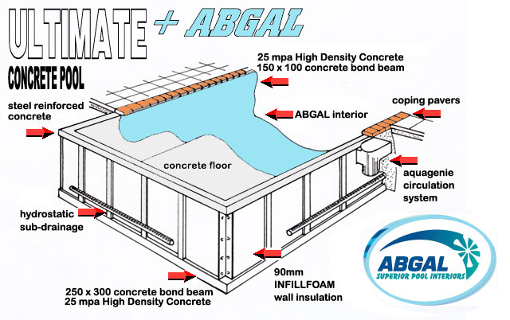

This range is available with either square or radius (150 – 300 – 600mm) corners on all rectangle pools, the standard walls are 1,100 mm tall and can be as high as 2,200mm for out of ground applications and the pools come with .770 Aqualon interiors, the Aquagenie system, two lights, Ozone, 90mm insulation foam and a swim out egress. We also include all the construction components needed to build the pool, a comprehensive Pool Owner’s Manual and Pool Tools set including start-up chemicals

Of a far more robust construction consisting of 25mpa 10mm shotcrete mix with a 150 x 100 top & 250 x 300 bottom bond beam, these pools compete head-to-head with a sprayed shotcrete pool - but with the added advantage of an impervious Aqualux interior which keeps the potentially harmful chlorinated water away from the concrete pool shell and it's fragile 8mm white plastered or 1.0mm painted interior.

The ULTIMATE pool range sells for approximately 25% more than the CLASSIC range, and is the top pool available in the country.

With all the permutations available, tall walls, radius corners, lower cost Basic pool range, patterned colors, you - the Authorised Cascade Dealer - have more ammunition than ever to get out there and make an impact on the pool buying public.

We compare the Ultimate pools favorably with sprayed concrete (shotcrete) pools - and as we reluctantly build a few shotcrete pools here in Auckland each year we consider the Aqualux Interior pool to be superior in many ways to a sprayed concrete and plastered interior pool - especially when the long interior guarantees, fully insulated walls, shorter installation time, and reduced maintenance costs are taken into consideration.

Aquagenie skimmer/chlorinators

The amazing Aquagenie skimmer has proven itself in the 12 years or so since we introduced it to New Zealand for the summer of 1996, and you should take advantage of this advanced skimming and chlorination system when presenting the Cascade product to the public.

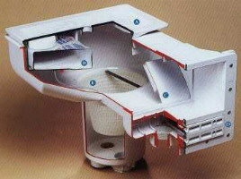

The Aquagenie – when used in conjunction with an Ozone generator – has the added advantage over other pool builders simply installing one or more eyeball water return nozzles in the pool wall, by shooting the return water downwards towards the pool floor. With the Ozone unit running, the Ozone gas bubbles are converted into micro-bubbles which take up to several hours to float to the pool surface.

This was an unforeseen advantage that only became obvious recently, but it really works!

In the 37+ years since we began installing the Cascade pool system in New Zealand, we have had many occasions to inspect pools built by us in the early 1970's and are proud to report that with minimal resurfacing and upgrading (a new Aqualux liner) these older pools look "as good as new" for a fraction of the cost of building a new pool.

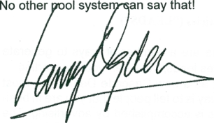
L.E. Ogden - Dip Pool Tech (NZMPB Inc)
Managing Director
The Cascade Roadmap
1
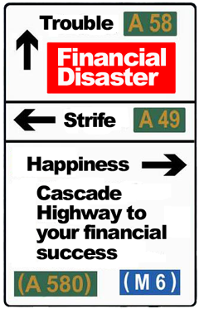

This handbook is intended to give you, our Dealer, the same information and advantage that we here at "Cascade Central" have enjoyed for over thirty years. If you follow the guidelines that are spelled out in the following pages, you will be treated to a time capsule of our accumulated knowledge in marketing the CASCADE swimming pool system. In effect, this handbook is a road map, a map of a journey from initial customer contact to final handover (and payment).

By following these guidelines, you will be assured of a trouble free association with your pool customer, and hopefully this will lead to even more sales as the satisfied customer recommends you to his friends and acquaintances as an efficient and thorough swimming pool company!

As with any well planned journey, there is always a starting point. In this journey, the starting point is generating sales inquiries (we call them "Leads")

Sales Inquires

There are a number of ways to generate sales leads, but when you are starting out as a new Cascade Dealer, the most obvious way is to tell people that you are in business. This is accomplished by advertising. The most effective advertising venues are the Internet, the Yellow Pages, and the local Daily papers.

Advertising

www.cascade.co.nz

The Internet is a full-time 24/7 advertising medium that has become vital as a source of information to prospective clients.

We endeavour to keep the Cascade web site current and interesting, and consider it to be a vital part of our promotional material.

Since the inception of the Cascade web site in 1996, we have registered more than 137,000 visitors, but more importantly, 127,000 of these have been since 2002! We are currently seeing 100 new visitors per day.

As part of our service to our Dealers, we give you a page on the Cascade web site which is reached by clicking on our DEALERS tab.

Do not hesitate to recommend any prospective client to the site and it is in your interests also to fully familiarize yourself with the contents. In the 21st century, you would be hard pressed to find a prospective client who does not have, or have access to, the internet.

As a professional person, it is essential that your main item of office equipment is a computer, and a speedy internet access via a Broadband connection.

We prefer to use email to keep our Dealers informed, so if you cannot receive e-mail, you might be missing out on strategic and valuable information.

We can issue you an “@cascade” email address, i.e. your_name @ cascade, so you look part of the Cascade organisation.

dave_smith@cascade.co.nz

Take advantage of this offer, it really ties your franchise into the Cascade home office, and gives your customers greater confidence than
dave_smith_family@yahoo.com!

Yellow Pages

This is a full-time source of product advertising, and their on-line product is one which is promoted by Telecom Directories to the extent that almost every-one at some time or other will look in the Yellow Pages book or on-line for a source for services or product suppliers. We consider this an important source of product inquiries, and feel that at least 20% of our leads come from this source.

There are some problems with the Yellow Pages:

- It is a passive form of advertising - obviously the customer must have already formed the desire to acquire the product prior to looking for a supplier. (In other words, the Yellow Pages does NOTHING to generate the desire for the product!) ..

- The Yellow pages is published only once per year - so there could be quite a wait for the new Dealer to get his first ad placed.

- It is EXPENSIVE!
Cascade has maintained a presence in the Auckland Yellow Pages for over 30 years, and our current (2007-8) advert cost us over $40,000. This is a high cost, for a publication that is diminishing in importance, so we may re-think our position on using this media for the next financial year.

Nevertheless, it is a significant source of sales leads and perhaps should not be totally ignored.

Newspapers

Most people read or are exposed to the daily newspaper. Our experience tells us that the National dailies are the most effective print media.



The "free" or "community" papers seem attractive as often their rates are very modest, however it seems that not so many "pool buyers" read the local papers as the inquiry rate from these newspapers is often dismal.

We use the New Zealand Herald, and from September until April each year try to run at least one ad per week (see sample Ads). Often in September and October and in the summer months we run two ads per week. We like Wednesday and Saturday.

Other week-days seem less effective. Sometimes we run ads in the Sunday national paper, although, with nationwide distribution, leads are generated from far flung reaches which we often cannot service.

Hopefully as the Dealer Network expands this advertising venue will become more relevant and we will re-examine this newspaper.

Our suggested DAILY NEWSPAPER advertisement is a 2 column x 10cm and we subscribe to the established theory that repetitive advertising is more effective than "full page ads" once per month.

We like "family" themes, such as "Enjoy Life - start at your swimming pool" and “Christmas Break by your Swimming Pool" and like to encourage the "Family that plays together, stays together" theme.

We are currently using the slogan:

“CASCADE – helping you spend more time with your family”

As our advertising logos and themes are all produced on our in house Desktop Publishing computer, we are able to quickly develop alternative themes, and are happy to produce Advertising PDF files for your specific need or desire.






We Stress the "Family" theme, and the fact that Cascade is the LOWEST COST and LEAST TIME CONSUMING pool to take care of!

“Cascade Pools – Helping you spend more time with your family.” – a simple but true statement!

Other advertising media

Business Cards

We provide you with CASCADE business cards. We realise that some of you have parallel business interests, and probably have a dedicated business card for that enterprise. Rather than load up a card with several businesses, we prefer to supply you with a dedicated Cascade card which has the same theme to all Cascade staff and Dealers. Just let us know the details you want on them, and we will provide them for a nominal fee

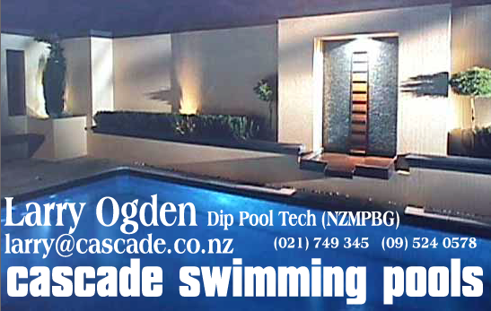

Mail Drops

We have tried alternative media such as letterbox mail drops (less than 2% results) and drive time Radio (limited response) so don’t suggest you try these.

Our web page generates a reasonable number of leads, and we will always send them on to you.

Product Inquiries

Hopefully your advertising will generate inquiries (Leads) - probably by telephone. Make sure that whoever answers the telephone has a happy face!

(What.... I hear you gasp! No one can see your face over the telephone!)

NOT SO!
People can "hear" your face when you talk on the phone!

No one likes to be on the other end of a grumpy telephone conversation, so ensure that whoever takes a sales inquiry call has a happy and positive attitude

…. ALWAYS


- otherwise ..…

Don’t Let Them Answer The Phone!

This section applies to your answerphone message too! Write out a script, review it and when you are happy it says what you want to say, record it! Don’t make up something as you go along – it does not portray a professional image!

Just ask yourself - how many people would YOU buy from you if they answered YOUR telephone inquiry with "WHAT DO YOU WANT!",
Instead of

"Cascade Pools, how can we help you?"

Project a friendly and positive attitude at all times. People are sensitive to your TONE OF VOICE and will prejudge THE COMPANY based on their initial contact with staff (or even yourself).
This might sound STUPID to you, but the Next time you answer the telephone, SMILE as you talk! Believe it or not, the difference is NOTICEABLE to the person at the 
other end!. You will even notice the difference yourself

Filling out the Lead Sheet

Always use the PRODUCT INQUIRY SHEETS! ………No Exceptions!

Many good leads have been lost to the competition because someone taking the inquiry jotted it down "on a scrap of paper" and it was subsequently misplaced, and the pool sale was lost because "no-one from CASCADE called us back".

Think of it this way: A $1,500 ad might result in 5 inquiries - so each call cost you $300 each to start with!

Out of every 5 inquiries you might sell one pool worth $35,000!, the problem being that you don't know beforehand WHO IS GOING TO BUY from you! So in effect EVERY INQUIRY is worth potentially $35,000 to you!

Do you still think that jotting down a $35,000 lead on a scrap of paper, or your blotter (where you might forget what the message referred to a few days later) is a good idea?

Obviously not.

Product Inquiry Sheets

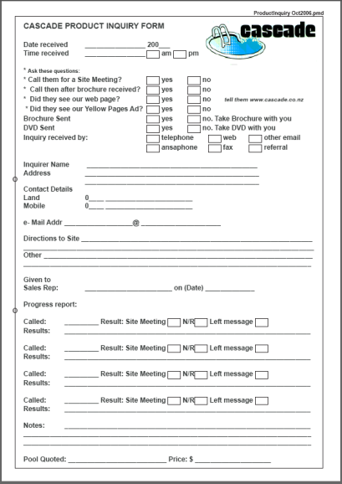

Use the Product Inquiry Sheets. Have several around the office or shop. DON'T LET STAFF USE THEM FOR DOODLING or for ANY OTHER PURPOSE than Sales Inquiries!

These Sheets are an integrated part of the CASCADE ROADMAP and should be treated accordingly. Give a copy to whosoever will be contacting the customer, and file copy away in a safe place. Periodically (two weekly if you are busy) check the progress of the inquiry with your sales representative. (EVEN if it's YOU!)

DON'T LET THE COPIES get lost. If no pool sale results to you, you still might have a useful sales lead for other products, especially if the inquirer purchased from another pool company.

They might require landscaping or service work at some later stage, so KEEP THEM ON FILE!

When filling out the Product Inquiry sheet, fill in as much detail as possible. There are specific ways to ask for personal information that will not intrude into your customers "private space".

If you receive an emailed inquiry from us, print out the email and use it as the Inquiry Sheet.
Dealing with customer telephone calls

Your initial telephone conversation with a prospective pool buyer might go something a little like this:

CUSTOMER: "I'm calling about the advertisement in this morning's newspaper. How much are your in ground swimming pools?"

CASCADE: “Our pools range from $??,000 upwards depending on size and shape. We have a very informative color Pool Buyer's Guide and DVD presentation which I can mail to you which explains at the details. Where shall I send it to?"

CUSTOMER:"Yes please, send the Brochure, to (Such and such address). Can you tell me how your pools are constructed?"

CASCADE: "They are basically a fully insulated steel reinforced concrete pool with an Aqualux internal finish. The pool structure has a 25 year guarantee, and the internal finish a 20 year guarantee. The free Pool Buyers Guide discusses all types of pools so you can compare the different types and decide which you prefer. Also the Cascade web page has a large amount of helpful information on swimming pools, which you should find very interesting.”

CUSTOMER: "Thanks, I look forward to receiving the brochure"

There are a couple of things to note in the above conversation:

- Don't discuss too much on the telephone. Especially don't let non-sale trained staff discuss the pool construction with a telephone inquirer.

- The Pool Buyer's Guide is designed to inform the customer, and the pricelist will qualify them in respect of their budget. It is a mistake to try to "pitch the sale" over the telephone. You must meet them face-to-face to present the CASCADE story effectively. (Qualifying a prospective customer means telling them up-front how much the pools cost, so you don't waste time and effort to be told they only have less than a $10,000 budget" – unless you can “up-sell them”).

- Note the subtle way the customers address was inquired. Often people will withdraw from a direct question such as "WHAT'S YOUR NAME AND WHERE DO YOU LIVE?" and respond with "Well, I'm just thinking at this stage and will get back to you". CLICK.

- You just blew it!

By asking "Where shall I send the brochure, even before asking their name, it "depersonalizes" the question and makes it seem less of a personal intrusion.”Where shall I send it" is NOT the same as "Where do you live" funnily enough! This is called "Soft Sell" in the trade.

- DON'T get into any further telephone discussion on pool construction - it's easy to portray the WRONG IMPRESSION of how the pools are built and make them seem less that they actually are. You MUST get the opportunity to let them see the brochure and read the enclosures, so that they fully appreciate HOW GOOD the Cascade system really is.

Sending the Color Brochure Pack

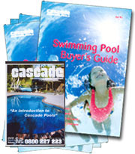
We don't scrimp on the brochure and enclosures. These are designed to lead the potential customer down a well defined path which culminates in them purchasing a Cascade pool from you.

As a service to our Authorised Dealers, we will send a Brochure Pack to inquiries from your area. There is a small charge for this, but it is well worth the few dollars for your prospective customer to receive the full package. A great amount of time and effort has gone into the design of the Pack, so use it to your advantage.

The Brochure Pack includes:

- An ULTIMATE SWIMMING POOL DVD
- Our Six Essential Steps FREE GUIDE
- 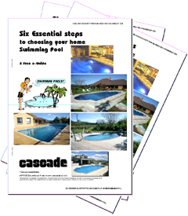
- The SWIMMING POOL BUYERS GUIDE
- An ULTIMATE Price List
- The Introduction from the NZMPBG Letter
- Our ECOLOGICAL Color Brochure
- The Slatecrete Paver Chart
- An ABGAL INGROUND POOL LINERS Brochure
- An AQUACAL HEATWAVE Color Brochure
- A FILTERMASTER Swim Jet Color Brochure
- A FILTERMASTER Water Blade Color Brochure
- A FILTERMASTER Euro Pump Range Color Brochure
- A FILTERMASTER Ozone Generator Color Brochure
- A FILTERMASTER Eco Pure Sand Filter Color Brochure
- A FILTERMASTER Hot Water Heat Color Brochure
- The HELICOL Solar Heating Options Brochure
- A Provista Glass Fencing Brochure
- A Leaweld Fencing Color Brochure
- The Moduline Pool Fencing Specifications Color Brochure
- The “NOW WHAT” Cascade Color Brochure on what to do next.

This adds up to $13.50 or $14.00 cost - so treat each inquiry SERIOUSLY and follow up on them. (Contents may change from time to time)

We charge you $5.00 + GST each for the Packs! They are a bargain!

Making Site meetings

Follow Up the Brochure
Use the Video as an excuse to see them


About a week after we send them the Brochure Pack, call the Prospect using "I am calling to see if you received our Pool Buyer's Guide and information pack and have had a chance to watch the DVD video?" Assuming that they did and they have read through the literature, try to make an appointment to see them. If not, you may have to give them more time, so be polite and say “OK – I will call you again in a week or so” – then do so! If they have looked at the information, try for a face-to-face meeting with them. Always try to see both husband and wife together. It saves heaps of time going through everything again if you only see one of them, and he/she asks “can you come back when (insert name) is here?”

A good approach (soft sell again) is to indirectly commit them to a site meeting …..

CASCADE: "We provide a free site inspection and written quotation, and I’m sure you would like all the facts and know the costs of installing your own home swimming pool.

Our quotation includes estimates for pool fencing and surrounds – so you will have an idea of the entire pool project by the time I am through. Many other pool companies just tell you the pool price, and leave you to find out the total costs by yourself.”

CUSTOMER: "Yes, that sounds OK"

CASCADE: “I can have a look at your site and give you a written quotation for a pool. When is a good time to catch you and the family together? Is Saturday morning the best time, or one day after work?"

CUSTOMER: "Saturday morning is no good as we all go to the supermarket, how about after work one day this week?"

CASCADE: "OK just tell me when it suits you and I'll be there!"

You will see by the above, that we avoided any direct questions which could result in "NO" being the answer:

Another example is:

"Is Saturday Morning the best time, or one day after work" gives him/her the option of only three responses"

- Saturday Morning
- After Work – or
- She decides a time to suit the family.

This is an example of soft sell which rarely fails.

The site meeting.

Dealing with the lady of the house:

In Auckland, almost all of our negotiations take place with the lady of the house, although I note that this is not necessarily true of other areas

In country areas, “the man of the house” is often the “boss” so you are dealing with a different set of imperatives when dealing with men or with women.

Women are more interested in the “green” nature of the pool, i.e. the ecological aspects, the recyclable nature of the product, whether her kids will have scraped knees from the interior, the superior warmth characteristics and the low pool chemical use of Cascade pools.

They will be interested to hear that we use the lowest noise pool pumps and heat pumps available in the country!

Mention how “Child Friendly” the Aqualux pool interiors are! How many little kids have had their feet (or worse) scrubbed raw by a plastered concrete pool finish!

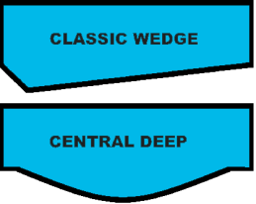
A good selling point to women is the shape of the pool floor as your opposition - esp. Fiberglass will probably not be able to offer them anything other than a classic wedge shape sloping floor – often with a severe drop-off in the deep end.

This floor shape is functionally useless for little kids who want to play basketball games in the pool! One of them has to stand in the deep end!

I always make a point of telling her that this can lead to squabbles in the pool, reducing the enjoyment.

I always suggest a “central deep” pool – the ideal shape for fun and games use of the swimming pool. Once explained to her, she immediately sees the advantage of this floor shape – and Bingo! your fiberglass opposition is out of the equation. You need to understand how a woman views a swimming pool, and tailor your approach to fit her needs.

I often used to say “a pool is the greatest baby-sitting device ever invented for hardworking young mothers” but was publically rubbished in letters to the editor in the NZ Herald after a 35 minute telephone interview with me was headlined “President of Pool Guild says pools are baby-sitting devices” Of course I took the heat, but what I actually said was “the overworked and harassed mothers of two or three busy five to seven year olds has an opportunity to sit by the pool – minding the kids – while she has a cup of tea, and maybe read a book.”

Of course this was the wrong thing to say, as Political Correctness today dictates that the mother must never be distracted while the kids are in the pool – even for hours on end – and sit there watching them without any distractions including a cup of tea or a magazine.

The general assumption was that I said it was OK to stick floatie armbands on the toddlers, chuck them in the pool, then go inside to vacuum the house! That, of course, was not my intention. I am very aware of child safety around pools, and pioneered voluntary Fencing rules in the 1970’s through the NZ Swimming Pool Association Inc.

Cost is often not such an issue with the ladies, but low impact issues such as noise and environmental issues are. Women are more likely to spend time at home with the pool and the children than the husband – so direct your sales pitch at responding to their needs!

Cascade is the exclusive supplier of the quietest pool pumps (the Silent Flo) and quietest Heat Pumps (the SuperSilent AquaCal). No other pool company has these items.

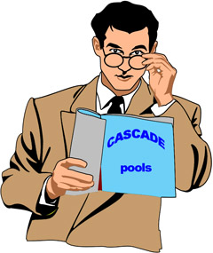
Dealing with “the man of the house”

Men are often more interested in the initial cost, and then the on-going running costs. They will show more interest in the construction and durability of the product. They generally have outside hobbies such as golf or fishing, so a swimming pool is not necessarily on their “top ten” list. Still – they will go ahead with the project “for the families’ sake”.

Mention the 550watt pool pumps – that act like one horsepower pumps, but use only half the power. Mention the 90mm pool wall Insulation that cuts heating costs by up to 50% and the Ozone that reduces chlorine costs by up to 85%. These are significant costs savings, and add up to more than $16,500 over a twenty year period (the average time a family home is occupied before the kids grow up and leave home)

Mention the Micro Media supplied with every Cascade pool filter – a further saving of up to 30% in water costs – giving the cleanest water possible, with far less backwashing.

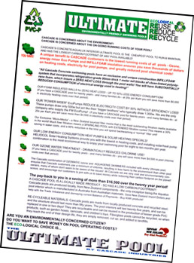

Familiarise yourself with the Ultimate environmental page we send out.

The DVD script is a "sales pitch" in itself, and you should watch it a few times over to familiarize yourself with the script. All major aspects of the pool construction is covered and although the promotional video is not intended as a construction manual for installers, will give them an idea of how the CASCADE pool is constructed.

The Pool Construction Manual for Ultimate pools is included later in -or attached to- this Dealer’s Manual.

If you are asked any question that you do not know the answer to, either make a note of it, telling the customer

"I'm not sure of that, so I will find out and get back to you"

… or call me (Larry Ogden) on 021 749345 which is my mobile number and I keep it on from 8am until 6pm each day.



Don't FUMBLE or MUMBLE! -- Baffling with “BULL” does not work

If you are stumped by a question DON'T FAKE AN ANSWER, you will look FOOLISH if later on your answer is found to be wrong!



We have HISTORY!
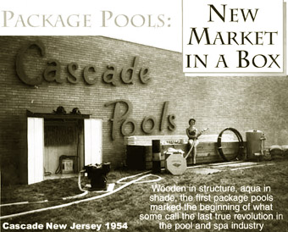
SELL THE BEST
– BECAUSE IT IS THE BEST!

… not because it’s the lesser of two evils!

Don’t try to convince them that our pools are “not as bad” as other pools – because “they” will be telling him the same thing!

We at CASCADE know that we build the BEST POOLS in NEW ZEALAND, and have more than 7,900 Customers to prove that our pools are TOP QUALITY and LONG LASTING.

Don’t Rubbish the opposition!
If you are asked to comment on another company's pool, keep your comments to a minimum! DON'T say detrimental things about someone else's product, it will only lead to a "trade war" that no one will win, and could "put off" the client from buying a pool completely.

Here's an example:

Fiberglass Boat-builders

Companies A, B and C

A potential customer for a fiberglass boat calls three companies for a quote. This man has never owned a boat before, and fancies himself going on fishing expeditions.

Boat Salesman (A) calls, and when informed that the customer is getting three quotes ....proceeds to "rubbish" Boat-builders B and C

"Their boats Leak"
"Their boats get OSMOSIS"
"Their boats delaminate within 3 years”... and so on.

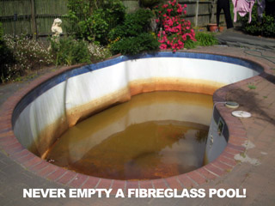
Next comes along Boat Salesman (B)
His comments on the opposition are along the same lines, only this time about Boat Builders A and C:
“Their boats fall apart
"Their boats get CRACKS"
"Their boats fade and discolor"

Starting to get a little disillusioned, the customer calls on Boat Salesman (C)

He too, is a "rubbisher" only …you guessed it this time it's A & B who are the "bad guys",

"Their boats get BLACK SPOT"
"Their boats use CHEAP MATERIALS"
"Their boats will sink"

The customer, who knew very little about boats a few days ago, now has a store of knowledge passed onto him by so called "experts" in the boating field, the Boat Sales Reps.

He now knows that:

Boats get BLACK SPOT
Boats are built with CHEAP MATERIALS
Boats are likely to sink
Boats fall apart
Boats get CRACKS
Boats fade and discolor
Boats Leak
Boats get OSMOSIS
Boats delaminate within 3 years

The "customer" gave up the idea and bought a Camper Van. Fortunately for him, the car salesman made no comments other than "This is a fun vehicle, which you enjoy many years of enjoyment."

GET THE MESSAGE?

The best comment you can make about another system of pool building is to say "CASCADE have been building these pools in New Zealand since 1971 and have more than 7,980 happy customers. I don't know if (insert other pool company name here) can say the same" - and leave it at that!

Don’t start a war - You will regret it!

If you MUST comment on an opposition pool – because you are cornered by something the customer says he “has heard about Cascade”* don’t rubbish the other product, just be subtle and introduce “doubts” without actually sticking your head in a noose!

*The problem with having nearly 8,000 pools built since 1971 can draw unfair comparisons, as someone “might know someone” who has a Cascade pool that is “looking sad”.

The problem might be that the pool was built in 1978 and needs refurbishing – quite a simple job. This argument (that Cascade pools “look shabby”) is as valid as saying “don’t buy a 2009 HSV Holden, because a mate has a Holden and it’s all rusty”.

The problem is that his mate’s car is a 1974 model – and cannot be simply refurbished!

For example: The customer has heard that vinyl liner pools are no good, the liner splits etc.

That’s why we have a 20 year guarantee!

Explain that the “liner” word just indicates the interior finish of the pool, and we have chosen a waterproof membrane (a.k.a. Liner) because of the long life and durable nature of the product. In fact, we give it a TWENTY YEAR guarantee. The Structure is so strong that we give it TWENTYFIVE years, and that if he prefers we could fiberglass the interior, or paint it, or mesh it and plaster it. But NONE of these interior finishes will be as good as the ABGAL Aqualux liner!

Guarantees

Yes, he says, “but they have a LIFETIME guarantee!”

Ask him – who’s lifetime? Yours, their company’s ….. who’s lifetime are they guaranteeing it for? These are MEANINGLESS words. Ask if they have given a SPECIFIC TIME GUARANTEE on the structure or interior finish like we do. I love to give a lifetime guarantee – I’m 68 years old.

With Cascade, when the interior is due for replacement – replace it! A One Day Operation!

With FG its “rip the shell out and replace it”.

Cascade’s warranty/guarantee is fully transferrable for the length of its duration. This is a great feature if – say after ten years – the family wants to sell and move on, the pool structure has a further 15 years of transferrable guarantee remaining and the interior a further 10 years!

This feature guarantees you a great many years of repeat sales to this customer, in the form of annual checkups and – if you want – chemical and valet sales.

Other useful information to use when combating FG pools:

- They have quite sloping interior walls (so they can get them off the moulds) so little kids can’t stand as close to the edge.

- They often have dangerous “sudden deep ends” which are hazardous to little kids, and they don’t have “play friendly” central deep areas.

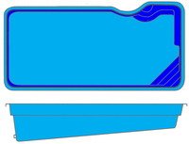
Notice the steep drop-off!
Not exactly “child friendly”!

- They don’t come standard with copings and if they get copings fitted as a $2,500 extra, the gap underneath on the water side is so ugly, you are forced to add a $3,500 mosaic tileband to cover it. This could bring the price closer to your quote

- They charge extra for lights and chlorination (usually 1970’s technology Salt units) which can add $3,000 or more to their quote!

- They are fundamentally purchasing 750kgs of PVC resin and glass strands. Conversely the Cascade pool contains many tonnes of high density concrete and steel. For a similar cost!

- In Australia a similar pool sells for $16,500.00 yet they want $30,000 here so you are paying through the nose for Australian land transportation to the shipping company, ocean transportation, to New Zealand, NZ customs fees, duty, GST on transportation & duty, local trucking costs, local storage costs, trucking to site costs, crane costs not to mention the labour involved. You might ask yourself why anyone would bother!


- Conversely, you can purchase a locally built Cascade pool, using New Zealand steel and New Zealand concrete, New Zealand installation crews and New Zealand sales and factory staff – yet the cost is not that different!

These are a few discussion points you can use when comparing apples with apples.

Remember that the “opposition” uses words with a subtle “dark image” to describe our pools: they are “vinyl pools” while theirs are “fiberglass pools” and of course there are “concrete pools”

Actually, these names are incorrect and misleading.

Both a fiberglass pool and a Cascade pool liner are substantially the same thing: the correct term is “Chlorinated PVC thermoset” and “Chlorinated PVC thermoplastic” – the difference being that FG pools go through one further process that “hardens” the PVC making it rigid, but with the disadvantage that it can never be recovered from the process (read: non-recyclable) whereas the virgin vinyl thermoplastic liners we use are recyclable back into basic PVC material which can be used for non-structural uses such as garden furniture, kids toys, and other non-virgin PVC use.

One major difference is the thickness: our liners are .75mm and this forms the waterproof barrier, but of course the pool shell is substantially waterproof as well – providing you put sealant between the panels during constriction, and then tape the joins.

The “waterproofing “ barrier on an average gel-coated FG pool is only as thick as a sheet of paper and can easily be scratched through to the glass fibers beneath – a potentially bad situation for the pool, as fiberglass strands are hollow and will absorb water and EXPAND to crack the pool surface. This is usually fatal to the pool, and would require a replacement shell.

A “concrete” pool can be a plastered porous block wall, a sprayed shotcrete pool, or a “box and pour” pool (there are other concrete construction methods as well, but let’s keep this simple).

Any given concrete pool may have a plaster interior finish, a vinyl liner, a painted finish, or even a fiberglass interior and the hope is that the pool shell is “waterproof” if the interior isn’t.

So these pools should called

A Plaster lined pool
A Gel Coat pool
A Vinyl liner pool

See how they use subtle descriptions to down-rate our pools?

Make this point to your customer!

We sell the Ultimate pools as Concrete Pools with an Aqualux interior.

Quotation Forms
We want you to supply the prospective customer with a written quotation for the pool of his choice plus the "extras" that he/she might desire, such as pool lights, a heater, etc.
(Note that pool lights are always supplied in twos - as one alone is insufficient to adequately light a swimming pool. For pools over 10m use an additional light for every extra 3.6m of pool length).

Remember, until he signs up for a pool he is a PROSPECT not a Customer – so keep the pressure on and use the professional forms we supply!

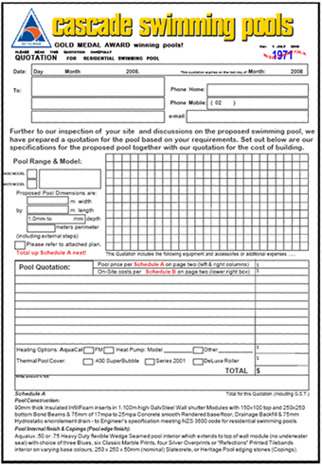
USE OUR QUOTATION FORM!

The Quotation for Swimming Pool form has spaces for the relevant customer details, and by using a carbon paper and blank sheet (not supplied by Cascade) so you can keep a record of the quote for your own files. On the front page of the Quote Form is room for the pool details and list price, and room for extras such as a Heat Pump and Thermal Pool Cover.

The TOTAL price is a combination of several components, as outlined in Schedule A and Schedule B

Schedule A: Lists all the current components of the pool kit, such as filtration, lights, etc on the left side of the page, and “Additions to standard pool specifications” on the right hand side. This column includes extras such as extra pool depth, extra skimmers, internal seats and egress features

(Egress is a fancy word for “exit”. We don’t call these features “steps” or “stairs” as the Building Act 2004 has decreed step riser heights which are incompatible with using this feature as a place to sit in the pool)

Schedule B; Lists additional costs such as excavation supervision where overburden must be removed in a compatible manner, Fees for the MH DESIGN Engineer, his PS4 Fee (where applicable) water costs, and out of town mileage and motel costs.

This form is designed so you MAKE MONEY out of each job – so USE IT!



A box beneath the item lines column of prices allows you to total up the full quotation. Write the full amount out in writing, so there is no confusion in your mind how much the quotation is meant to be for.

The Quotation for Swimming Pool form continues the theme of soft sell and gives the customer both a written quotation plus further selling points on the Cascade system.

Also included are the "exceptions to the quotation". These exceptions are reflected in the Sales Agreement also, and will give the prospect a good idea of what to expect from Cascade.

The area with the heading “Exclusions: Please be sure you understand these exclusions!” should be used to remind the customer that the installation could be hampered by unusual site conditions, or the requirement to remove soil or order a water tanker to fill the pool - all of which it should be noted here that these are the financial responsibility of the customer.

By estimating these extra costs, you will be able to give your prospect a fair idea of what they are going to be in for as far as the total costs are concerned ... but stress that these are NOT a quotation from you, but rather a "best guess" based on your experience.

In summary the quote form reiterates the benefits of the Cascade system, including the unique Aquagenie skimmer, and closes with a few historical notes intended to give the prospect the confidence that he is dealing with a pool company of reliability and substance.

There is a space on page four for you to stamp your company logo and telephone numbers. Don't forget to put your details here.

The Quotation forms can be photocopied in black and white on A3 paper, but we prefer that you buy the full color copies from us for $3.50 +
GST as it reflects a more professional presentation and are bound to be more attractive than your opposition's quote which is often just a letter to them.

There is a copy of the latest version of the quote form, as of June 2008 included later in this manual.

No Negatives

Someone once said that "the path to a successful sale is the removal of all objections in the customer's mind"

The entire Cascade system - from Brochures & Pool Buyers Guide - to Video Presentation DVD - to Quotation Form - is geared to portraying a positive approach - so don't introduce any negatives into your conversation with the prospect.

Try to eliminate “Negative” (No!) answers.

One example of how to lose a sale is by asking a blunt question that can be answered by "NO" - thus ending the dialogue ... for example

YOU: "Will you buy a pool from me?"

HIM: "NO"

...What do you do now???

How about this instead?

YOU: "Aren't these pools beautiful?"

HIM: "Yes"

YOU: "Every family with kids really benefit from a pool, don't you think?"

HIM: "Yes"

YOU: "Wouldn't it be great to have a pool at your home, and wouldn't your kids love it?"

HIM: "Yes"

YOU: "If we could organize it so that you could enjoy this luxurious lifestyle for this less than $20 per day* wouldn't that be an attractive offer?"

HIM: "Yes"

YOU: "Well, we need to document the arrangement, do you have a rates demand so we can fill in the forms and get this under way?"

HIM: "Yes, I'll go and get it!"

See the difference, all POSITIVE questions that would be difficult to answer with a NO!

- * $20/day = $600/m or $60,000 loan over 15 year table mortgage at 8.75% interest being offered by Kiwibank September 2008

Following up the Quotation

After no more than two weeks have passed, call the prospect to inquire if there is anything else they need to know about.

Usually (although not always) the prospect will call you with an acceptance, but if more than a couple of weeks has passed without hearing from them, there is a possibility that you were not successful with your quote (but not necessarily, sometimes they "sit on" quotes for a whole season, then call you next year! This is NOT uncommon, which is why our quote forms have an EXPIRY DATE).

Presenting yourself

The most often reason given for purchasing from one pool company over another (when all things seem equal) is, oddly enough, not the product or service, but the SALES PERSON! They feel that “they can trust you!”

People will NEVER purchase anything from a sales person that offends them for some reason. Sometimes offence may be inadvertently given for a number of reasons you might never think of.

Some examples are:

- Swearing (even mildly, and even if the "man of the house" swears first!)
- Lighting up a cigarette in front of them (who smokes these days?)
- Body Piercings
- Tattoos(that are not of Military origin)
- Turning up with the remnants of a "beer at lunch time" on your breath(definiteNoNo)
- Dressing untidily, or with dirty "tradesman's clothing"
- B.O. (body odor)
- Turning up in a wreck of a car that drips oil on their driveway (how successful do you look?)
- Being "overly friendly" – especially to the woman of the house (Nothing even remotely smutty or any ogling!)

If the prospect introduces himself/herself as "I'm John Smith" then it's probably OK to call him "John" - and introduce yourself in a similar manner "I'm Larry" etc.

If he says "Mr. Smith here", continue to call him "Mr. Smith" until he says otherwise.

There are many more examples which you will think of. Just remember to be "neutral" in appearance and behavior to avoid unintentional offence.

Xenophobia

We all feel this – xenophobia – a fear of strangers! How often - when confronted by a stranger – do you take “a few minutes” to size them up, and assure yourself there is no danger? This is a perfectly normal flight response which has been inherited from our mammalian origins for ensuring our personal security.

Often the first 15 minutes of a site meeting are spent just "shooting the breeze" - discussing (non contentious) issues such as the garden, the weather, how nice their house is (you obviously have a flair for interior decorating).

You are trying to portray yourself as a "trustworthy person to deal with" so maintaining a positive and friendly attitude is essential – especially if the prospect is a woman and the kids are at school and the husband at work. Even if she is in a bikini – keep your eyes in check! Don’t think she won’t notice!

Keep it safe and friendly.
What to do if turned down!

BE GRACIOUS!
Don't be tempted to let your disappointment show!
“WHAT!!!” - “You accepted WHO'S (expletive deleted) Quote???
(It's difficult, as most sales people feel personally affronted if they are rejected!)

Most often, they don’t call you to tell you they have accepted another pool company’s quote. But sometimes it DOES happen!

Thank them for their time, and if appropriate, inquire who got the job, and for what reason, by saying "I'm disappointed, but would be interested to know where we went wrong so that I might improve our performance next time ".

Often people will not tell you the REAL reason, so don't take it too seriously - and DON'T make disparaging comments about the successful company. You never know, they might turn out to be no good, and the customer could call you back later.

I actually have sold several pools to prospects that initially rejected me. As always, I was charming and polite (even though my thoughts at the time were unprintable!)

It transpired that the first pool company somehow subsequently upset their customer, who gave them their “marching orders” and called me back. I graciously accepted their order and went on to build a lovely Cascade pool for a customer who was most grateful and appreciate that he ended up with a better deal than he originally had!

A Successful sale!

Assuming a successful conclusion to your sales pitch, you now need to fill out the Sale and Purchase Agreement for a Cascade Pool.
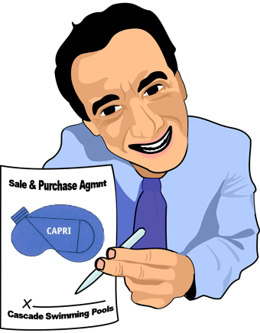
The form is self explanatory; however make sure you fill in all the relevant details, as you will be faxing this to Cascade Head Office as the order for the pool kit - so EVERYTHING you sold them must show up on the sales order.

It is best to ask for a “Rates Demand Notice” and copy the information from that to the “Sales and Purchase Agreement” as they tend to have most, if not all, the required information needed, such as Lot Number, DP, Valuation Number and correct name of the householders as registered with their local Territorial Authorities.

Signing the “Contract”

Our Sale & Purchase Agreement (it’s NOT a “Contract” so don’t call it by that term) has evolved over nearly 37 years of having customers put the “thumb screws” on us! It’s still a work in progress.

Check the private DEALERS section on our web page periodically to ensure you have the latest version. We update it several times a year, as new customers find new ways to avoid paying us.

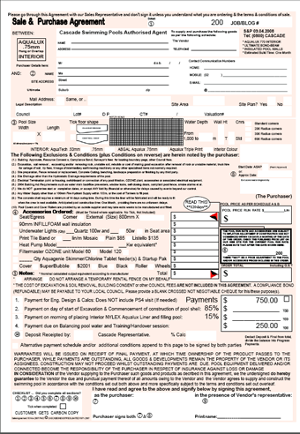

It sounds like a joke, but unfortunately when we are installing so many pools a year, we seem to unearth more unsavory customers – so USE THE Sale & Purchase Agreement we provide!

It is essential that you enter the Husband’s name at the top line in the second box, then his date of birth!

If queried on this requirement, I always say “it’s a security requirement – if I have to call him to discuss finances over the telephone, I need to establish that I am talking to the right person, so need a password. Don’t give me a dog’s name as we may forget what was said in a few months time, but he will always remember his birthday”.

In the five years we have had this requirement; so far I have never been knocked back.

The actual reason for the d.o.b. requirement, is that “if” you get into a financial wrangle with your customer, - usually over the 15% payment ( …you ARE using our Sale & Purchase Agreement aren’t you?) you can cite several high value items supplied (such as the Heat Pump, filtration plant and pump. Ozone unit etc.) which would total $8,000 to $10,000 being the same or more than your 15% payment which is being withheld.
You go onto a Government web site and register the customer as a customer, and add the equipment to the web site. It pays to have the serial number of the goods, if possible. This is possible under the Financing Statement Registration provisions of the Personal Properties Security Act 1999 at www.ppsr.govt.nz. You may need your accountant to assist here, as the site is not very user-friendly if you are not accustomed to filling in on-line Government forms.

Believe me – it’s worthwhile!

Notification of this registration is given to your customer in the Terms and Conditions of Sale on the reverse of the Sale & Purchase Agreement paragraph 9.0 item one, as is his agreement that you have right of access to the pool site while construction is in progress, or has not been “finished” in your opinion. This is useful if you “have to recover” a Heat Pump!

Note that there are two places for the customer to sign, and under the Consumer Guarantee Act (1993) any exceptions or omissions must both be told verbally to the client, and signed by him as having read them or they are ….

NOT ENFORCEABLE!

This also includes the Terms & Conditions on the reverse side of the sales agreement. Under the current legislation you must inform the customer verbally that these conditions apply to the sale, and that he/she should read and understand them, and that they have 21 days to refute the agreement fully. In the real world, this is unnecessary, as all they have to do is say “I’m not going to pay you " and obviously you wouldn't still continue and build the pool for them! .

Although the Sale & Purchase Agreement states that the goods remain our (your) property until payment is made, you must also state verbally that he must understand his rights!

What a tangle these Legislators get us into! They obviously do not operate in the same world us mere mortals!

The Deposit

We have standardized on $750 for a deposit as this is close to the usual amount that the structural engineer requires to process the Engineering Drawings and Structural Calculations, leaving a few dollars over in credit on your debtor’s ledger computer program. Don’t be tempted to take more than this amount and I will explain in detail if you want.

Changes in the District Scheme over the years means you must check with the Local Authority to see what requirements are being made on swimming pool builders, especially in respect to fencing the pool in accordance with the Fencing of Swimming Pools Act 1987.

For example in Auckland City, the proposed District Scheme no longer regards a pool as a "building" in terms of the Town Planning Scheme, so a pool may be constructed right up to a boundary. On the other hand, the North Shore City Council takes the opposite approach, and declares a pool a "building" which could cast a shadow, so therefore falls under the "shadow angle" legislation and must require Town Planning Approval as well as Building Permits.

Furthermore, the North Shore City Council deems a pool to encroach on "recreational space" and therefore restrictions apply to townhouse sites, where free space is at a premium.

It is not my intention to question the sanity of some of these decisions, but to declare that a swimming pool is a building which could cast a shadow, and is not a recreational area seems a little out of touch with reality. Nevertheless we are required to accommodate these rules when building pools in (Auckland's) North Shore City, so check with your local councils for equally weird legislation.

Customer Payment Terms

The Payment Terms Must Be
Adhered To!

NO EXCEPTIONS


Don’t let them run off with (y)our money!

In order for the successful disbursement of funds, you must collect 85% of the pool selling price on the day you deliver the pool kit and commence the installation. Our terms of payment from you are clear-cut and simple to follow:

WE WILL NOT SHIP A POOL KIT FROM THE FACTORY UNLESS WE HAVE A CHEQUE FOR THE KIT IN OUR HAND OR PAYMENT HAS BEEN TRANSFERRED TO OUR BANK ACCOUNT

We allow you 5 business days post dated cheques, this will allow you to secure payment from your customer, and bank his cheque to cover yours.

It is essential for the well being of your in ground pool division that this policy is adhered to. The 85% payment should be more than enough to pay us for the Pool Kit, your site materials, your installation crew costs, and your overhead recovery.

Equally, when the pool is filled, and the filtration is started up for the first time, you now collect the 15% payment. This payment will cover your PROFIT, so take care you get it! This, after all, is what YOU ARE DOING IT FOR!

This payment also allows for the purchase of Copings and the coping installer's fee.

In order to keep the pool division "clean and tidy" it is a good policy to pay as you go - i.e. pay the excavator on the day, the site materials C.O.D. and the crew when they are finished with their part of the installation.

Pay for the Copings and installer from the 15% progress payment and you will have a clear idea of the profitability of each job as it happens.

Ordering the Pool Kit

Notification to us of a sale is by faxing a copy of the sales agreement to us. In this way, we will see what you have included in your agreement, as often some extras such as Heat Pumps are sourced from other than Cascade stock. We will issue your customer a “Job Number”. The customers details are then entered in to our database which allows us to mail or email them periodically with updated information on the care of their Cascade swimming pool.

DO NOT ORDER ANYTHING VERBALLY as we will not act without WRITTEN ADVICE.

DO NOT CALL AQUATECH to discuss pool kits or components, unless it is OTHER THAN FOR CASCADE BUSINESS (i.e. other Aquatech products from the Aquatech Catalog).

Aquatech is not our sole supplier of pool kit components. Always ask Myles if you need to know anything about your order!

Aquatech is fully employed manufacturing the Cascade product and it’s other business of making Para Pool liners and pool accessories and has no desire to discuss your pool kit problems, site problems, or the philosophy of Cascade and the installing of in-ground swimming pools.

All Warranty problems should be notified directly to Cascade, who will bring any such matters to the attention of our supplier, arrange a remedy directly or advise you who to contact for the quickest resolution.

Building Approvals

Since 2004, Cascade Auckland no longer includes the Building Approvals in the published pool price, nor does it include the excavation in the price. We never included earth removal.

You may choose (or be forced) to do otherwise. This is your decision.

There are several distinct Local Body requirements for permission to construct a swimming pool.

These are:

- A Building Permit
- Town Planning Consent
- Resource Management consent

The Building Permit (also called Building Approval) investigates the suitability of the proposal under several sub-categories:

- Engineering & Design of the proposed structure - in this case the swimming pool

- Plumbing & Drainage aspects of the proposal, and the provision of disposal of waste water, as created by the backwashing of the sand filter.

- The Engineering Drawings must be specific to the site of the pool installation, and an original copy must be signed by the Design Engineer.

- We have an arrangement with Mehmed (Pronounced Mem Ed) to provide such a service to you for the sum of $500 + GST

- If you simply photocopy older plans from Mehmed and white out the previous name & address, you are STEALING from him. We do NOT condone this practice.

- If you do so, and the Council calls him for any clarification, and this job is NOT on his list of plans supplied he will report the theft to the Police. Is this risk worth $500?

The Town Planning Division will investigate the proposal in respect to its impact on the surrounding neighborhood and environmental impact, as well as "Cultural Significance". These requirements have gradually evolved into complex and demanding aspects of construction in New Zealand today. For example, under the 1994 District Scheme you were required to seek a Resource Consent to excavate the pool if more than 25 cu meters of soil are involved.

As this covers almost all in ground pools, it may therefore be construed that all swimming pool Building Approval applications will also need a Resource Consent for the excavation in this Council area. This would be correct, except that the granting of consent to build the pool also implies consent to excavate the "footings": therefore the Resource Consent requirement may be waived by the Council.

The District Scheme however may not actually require a "Building Permit" for a swimming pool, as some councils have decreed that a swimming pool is NOT A BUILDING, therefore it follows that a "Building" permit cannot be required!

You will have to sort out your own Council's attitude on these matters and until some unified district scheme is adopted there can be no hard and fast ruling on these matters

AS this is UNLIKELY to ever happen (as in the diverse interpretation of the District Scheme by the four Auckland Councils) you will have to "play it by ear"

Most Council areas in New Zealand have at some time or other been exposed to the Cascade pool system, and will often give what is known as "Blanket Approval", as the design does not alter from pool to pool. What does change, however, is the site.

A site plan at 1:100 or 1:200 is usually required, one which gives all relevant information on the physical dimensions of the site and includes the location and distance to the boundaries of the house and other developments, and the location and distances to the boundaries of the proposed swimming pool.

Also required is the location and direction of sewerage and storm water lines, and the location of Gully Traps plus the Gully Trap into which the back-wash from the filter is directed. Topographical information such as sloping land is usually required, and in some country areas a site location map is required so they can find the place.

Even though we rarely get involved in fencing, a substantial Pool Fence is required under the Pool Fence Act 1987 and must be shown on your site plan before permission to build is given. (As the Cascade Classic pool is usually filled the day immediately following plastering the pool floor, this is often prior to the permanent fencing having been erected, so we normally make some provision for temporary fencing to be installed before leaving the site).

Most pool fencing companies have a Brochure which illustrates the fence and gives dimensions, and most council’s will accept this as a "Design" drawing.

To facilitate your application for Building Approvals, we have contracted MH Design to produce an Engineering Drawing Plan for all our installations, plus an Engineers Statement and Producers Statement and PS 1 and B1 & B2 statement. These items are all available direct from them, or through Cascade.

Usually the Council requires an application processing fee up front, in Auckland this varies from $500 to $750, so you will need to get a blank cheque from your customer to pay for this fee. Make sure the blank cheque is made out to the Council and is suitably protected against theft and misuse.

Processing the approvals usually takes several weeks to several months or more (depending on the workload at the Council) but there is a New Zealand Statuary Requirement that approvals must be given within twenty-one working days unless there is some reason for a delay. Check your local Council for more details on this aspect.

Building Approval Summary

For application for Approval to construct a Cascade swimming pool you will need the following documents:

- Site Plan
  - Pool location to boundaries
  - Pool Fencing Detail
- Engineering Drawings which include:
  - Engineer's Statement
  - Producer's Statement
  - Construction system
  - B1 and B2 statement
- Customer’s cheque for processing fee
- Customer’s Cheque for Footpath Deposit (if req.)

The above may be required in triplicate!

Paying for the Pool Kit

As mentioned earlier, we will ship (or you can collect) the pool kit on a pre-determined day providing that you have sent or given us a postdated cheque for the invoiced amount. As all pool kits are "ex factory", freight is your care if you expect us to arrange shipping

Deal with Cascade

(Not Aquatech!)

There has been a tendency amongst some of our Dealers to call the Aquatech factory to discuss pools, as they are accustomed to calling Aquatech to discuss other product lines such as Para Liners, Pool Components etc.

Please be aware that any discussions regarding the Cascade swimming pool system should be addressed to us at Cascade Head Office on 0800 CASCADE. (0800 227 223)

Site supervision

Part of our service commitment to our customers includes supervision of the installation crew while they are building the pool.

Drop by or have your “Site Manager” drop by for 30 minutes or so each day - preferably after lunch - to gauge progress and check that the level of workmanship is sufficiently high.

Glance along walls (rectangle pools) to check that they are straight, and duck your head down to panel top level and sight across the walls to ensure that they are level (all pools).

Mistakes missed at this point are costly and a nuisance to rectify at a later stage, and can occasionally happen!

Check all (visible) plumbing is neat and professional looking. PVC pipe is easy to work with, but would be surprised at how many "cold" joints are missed during the fit-up stage.

Using colored solvent may help avoid this common problem. Believe me; it has happened to all of us! Even experienced crews occasionally forget to unplug a "trial fit" and glue up the joints!

Make sure the crews sandpaper each side of the joint, fitting AND pipe, and brush solvent ON BOTH COMPONENTS of the joint.

Don't let the crew "bury" any pipe joints until they have been "wet tested" with full mains supply pressure using the Pressure Test equipment you can purchase from Cascade for $250.00 + GST

Use only top quality 40mm & 50mm "Class D" PVC pipe and PVC solvent, and discard any solvent which has gone (or is going) off. This is especially important on hot summer days, when uncapped solvent might not last an hour in hot sunlight.

Installation Crews

If you are using a two man crew to install the pools, make sure that they "look the part". We have a range of T Shirt sizes to fit most people, and suggest that you give the crew a couple of T Shirts each at the beginning of each season, and a Cascade Safari Hat to keep them from getting sunstroke in the heat of summer.
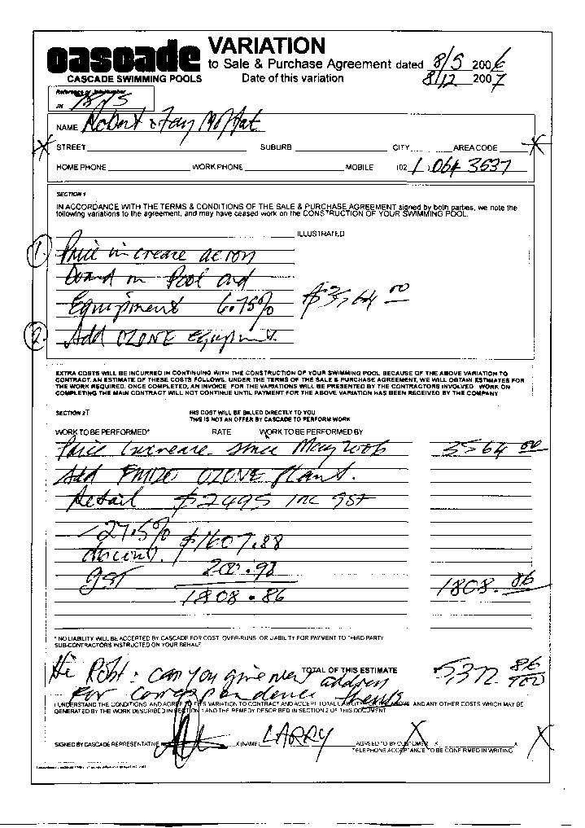
This applies to you too, if you are building the pools yourself.

We have a costing schedule for materials and crew rates which you will find later in this manual. These prices are "Auckland" prices, and may vary from place to place around New Zealand.
Installing the Cascade pool system can be broken up in to several distinct phases, each phase should be accomplished in one working day.

At first this might seem difficult, but these daily targets are easily reached by experienced crews and should give you an indication of how the installation should be proceeding.

The following “INSTALLATION PROCESS MANUAL for ULTIMATE POOLS” applies primarily to the Ultimate pool construction but can be applied to the Classic pool range as well.
Variations to the Sales & Purchase Agreement

If for any reason the terms and conditions of sale change between the time you signed the customer up, and the time you go to install the pool, several months may have passed.

The Sale & Purchase Agreement has a section to fill out which states the date of signing and the run rate used to calculate the selling price.

If several months have passed, the run rate may have been updated due to inflation, costs increases, the $US rising (or falling) and any number of reasons.

To preserve your selling price and margin, you should review these items with the customer and come to an agreement on any cost increase.
The pool shape and size may have changed, or a different pool model may be required.

Whatever the reason, you must use the “Variation to Sale & Purchase” which will document the changes, and which will be signed by your customer.

Above all things --- learn to “sell the sizzle” not “sell the steak”!

Talk about sultry and romantic summer evenings by the pool.

Midnight swims (when the kids are tucked up and asleep)

Healthy and enjoyable lifestyle

Tired out kids – after a day in the pool – they will sleep like logs!

All the above – in their CASCADE pool!

Annex A

The Dealer section of the web page is a great resource with many downloadable documents designed to help you with your Cascade dealership

These include:

- Ecological Pools page
- Excel Spreadsheets for calculating pool prices in your area
- Dealer Pool Kit quote form: Fill it out and fax back to us
- Four page colour Quotation Form. If you prefer, we will print some out for you, specific to your address etc.
- Sale & Purchase Agreement
- The latest Auckland price list
- Our contract rates for installation crews
- Ultimate pools under construction: a photo reference page
- Heat Pump price lists
- Product Inquiry sheets (photocopy-able)
- Installation Check List
- ABGAL Liner markout form
- ABGAL Liner order form
- Installations Costing sheet
- Pool Owner’s Manual – latest version (continually upgraded)
- Pool Owner’s Report – do you want to be graded by your Customer?
- A3 Site Plan blanks
- Dream Pool Survey
- PS3 Producer Statement blank
- Reliner Quote Form
- Subcontractors Agreements – protect your interests when hiring people to build your Cascade swimming pools
- Variation to Sale & Purchase Agreement
- Pool Completion Certificate
- Pool Water analysis sheet
- LOGOS to use on stationary
- Clothing – look the part with CASCADE logo on your clothing.
- Personal email account – you@cascade.co.nz
- Cascade Business Cards
- Material & Installation costs sheets

www.cascade.co.nz

click this tab on the lower left side of your computer screen

The current password is “ dealer05 ” (no quotes)

Not to be confused with the DEALERS tab on the top row!


TELEPHONES
We have several telephone contact options:
0800-CASCADE
(0800 227 223)

Main incoming line  (09) 5240578  admin@cascade.co.nz | Fax Line  (09) 5242431
Managing Director  Larry Ogden (021) 749345  larry@cascade.co.nz | Accounts Manager  Bridget Ogden (021) 502 494  bridget@cascade.co.nz
Sales Manager  Mike Coghlan (0274) 988252  mike@cascade.co.nz | Factory Manager  Myles Ogden (021) 336 754  myles@cascade.co.nz

Installation Manager
Baz Knudsen (759 521
baz@cascade.co.nz

The mobile numbers are available from 8 am to 6 pm - 7 days per week. (Summer months)

We dispense Pool Leads to our Dealers via email, it is essential that you avail yourself of this immediate communications method. If you don't, you are missing out on a vital communications tool!

General e-mail to cascade admin@cascade.co.nz

Internet Web Page www.cascade.co.nz

Visit the CASCADE POOLS home page regularly!

The DEALER section is password protected. Call us for the most recent password; this section is a valuable resource for you and a source of the most up-to-date information from Cascade. Use it!

